**Experiment 3**

Crypto Encryption

**Name:** Kashish Jain

**UID:** 2019130022

**Class:** TE Comps

**Objective: -**

The learning objective of this lab is for students to get familiar with the concepts in the secret-key encryption. After finishing the lab, students should be able to gain a first-hand experience on encryption algorithms, encryption modes, paddings, and initial vector (IV). Moreover, students will be able to use tools and write programs to encrypt/decrypt messages.

**Tasks**

Task 1: Encryption of plain text using different Ciphers

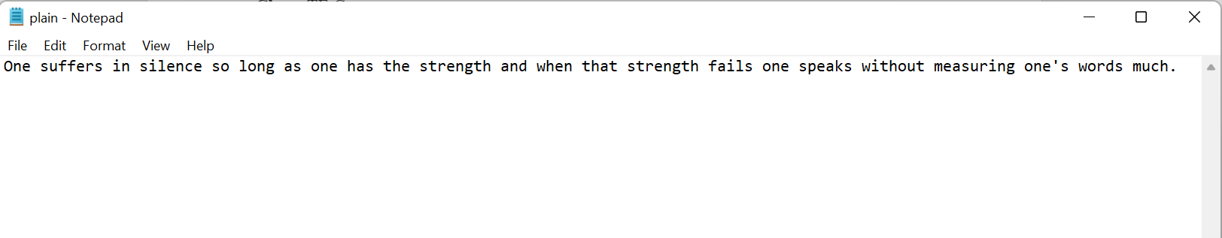

1. Encryption Using aes-128-cbc

In this no extra arguments were given.

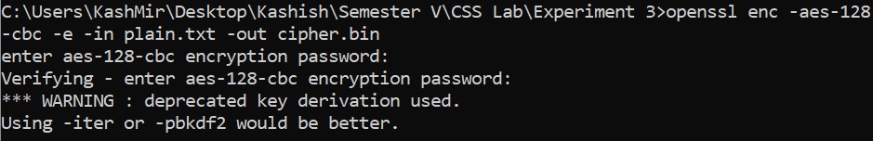

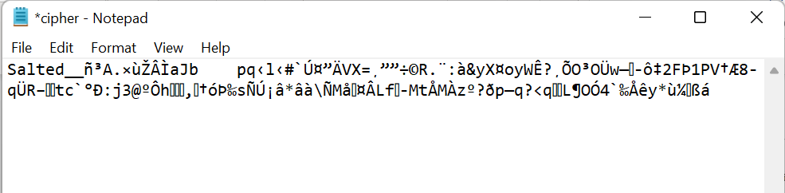

Decryption

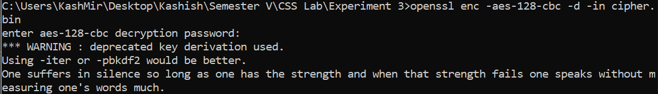

1. Encryption using des

In this instead of providing a password we provide a KEY and IV. If we do not provide these two arguments, both are generated automatically and can be viewed by adding -p.



Cipher File

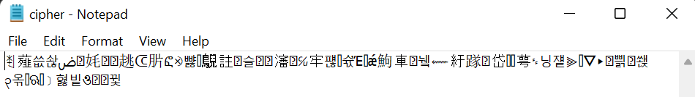

We can observe that here a password is not asked as both KEY and IV is provided

1. Encryption using bf-cbc

Password is provided as argument



Cipher File

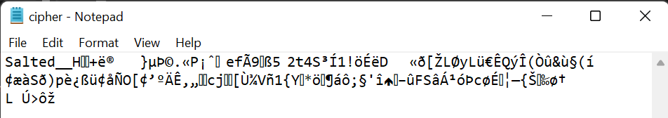

Decryption also accepts password as argument



Task 2: Encryption Mode – ECB vs. CBC

The file pic original.bmp contains a simple picture. We would like to encrypt this picture, so people without the encryption keys cannot know what is in the picture. Please encrypt the file using the ECB (Electronic Code Book) and CBC (Cipher Block Chaining) modes, and then do the following:

1. The file pic original.bmp contains a simple picture. We would like to encrypt this picture, so people without the encryption keys cannot know what is in the picture. Please encrypt the file using the ECB (Electronic Code Book) and CBC (Cipher Block Chaining) modes, and then do the following.
2. Display the encrypted picture using any picture viewing software. Can you derive any useful information about the original picture from the encrypted picture? Please explain your observations.

**Original Picture**



**ECB**

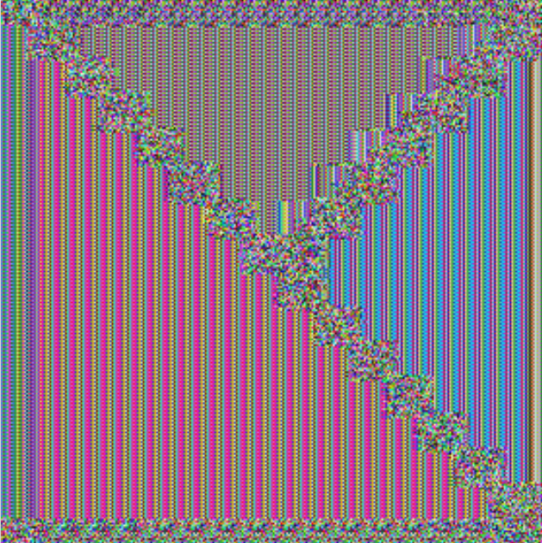

**CBC**



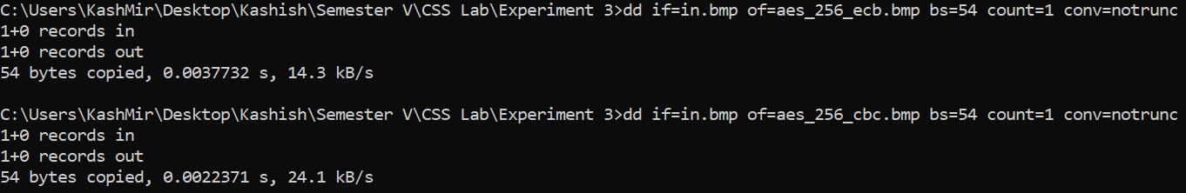

**Observations:**

* In case of image encrypted using ECB we can see somewhat outline and borders of the original image and figure out a rough shape of the original image by looking at it.
* But in case of the image encrypted using CBC the entire image is distorted and there is no way to find what the original image may look like. Hence CBC is certainly better for image encryption.

Task 3: Encryption Mode – Corrupted Cipher Text

To understand the properties of various encryption modes, we would like to do the following exercise:

1. Create a text file that is at least 64 bytes long.

2. Encrypt the file using the AES-128 cipher.

3. Unfortunately, a single bit of the 30th byte in the encrypted file got corrupted. You can achieve this

corruption using ghex.

4. Decrypt the corrupted file (encrypted) using the correct key and IV.

Please answer the following questions: (1) How much information can you recover by decrypting the corrupted file, if the encryption mode is ECB, CBC, CFB, or OFB, respectively? Please answer this question before you conduct this task, and then find out whether your answer is correct or wrong after you finish this task. (2) Please explain why. (3) What are the implication of these differences?

**ECB**

Original Encrypted Text

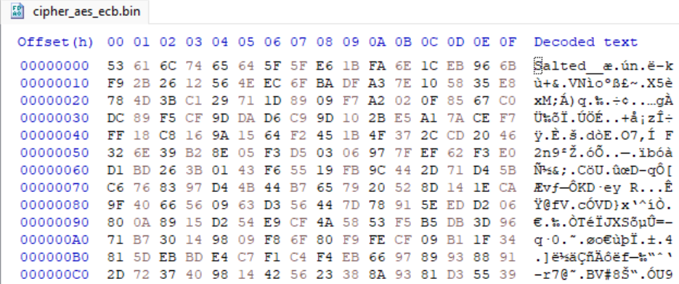

Corrupted Encrypted Text

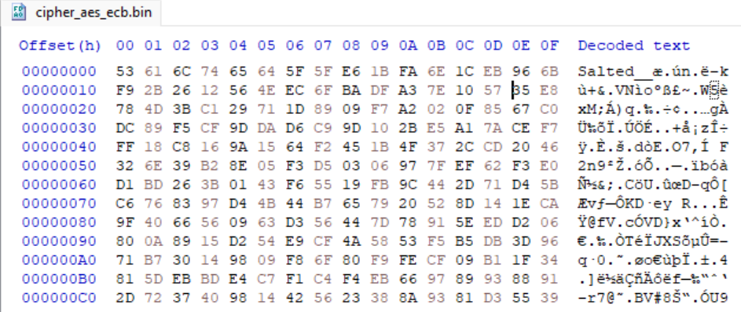



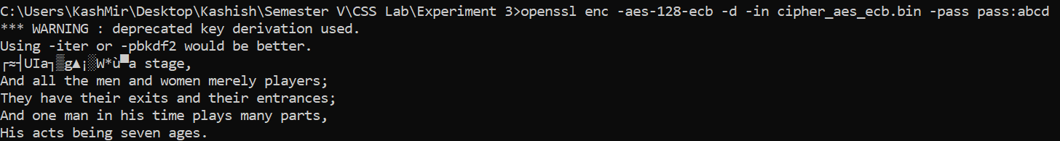

**CBC**

Original Encrypted Text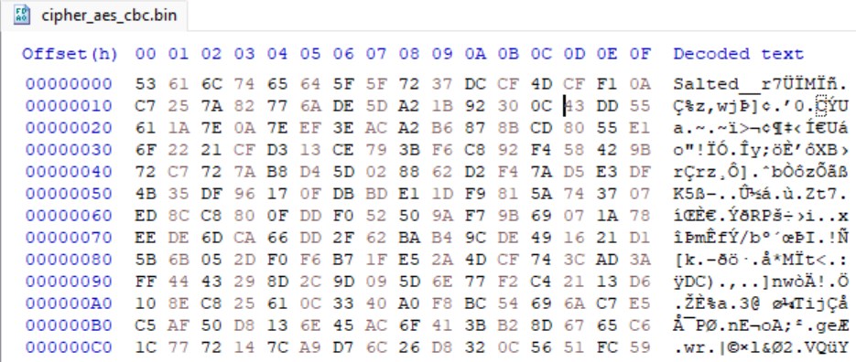

Corrupted Encrypted Text

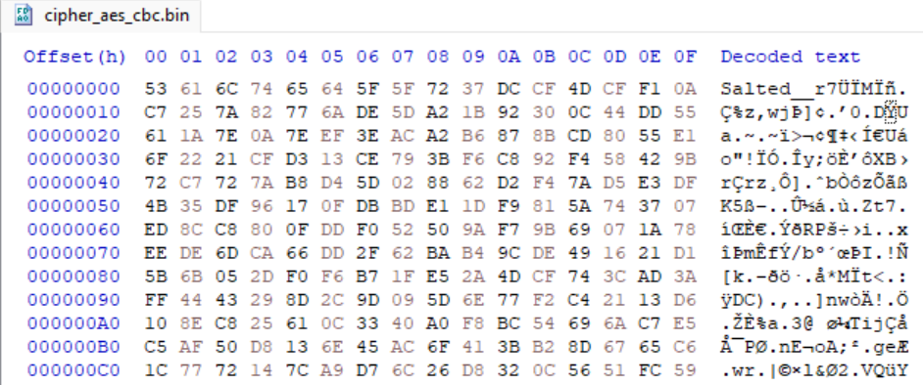

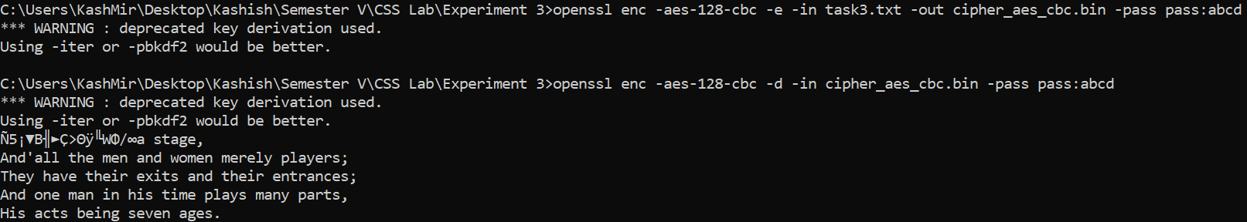

**CFB**

Original Encrypted Text 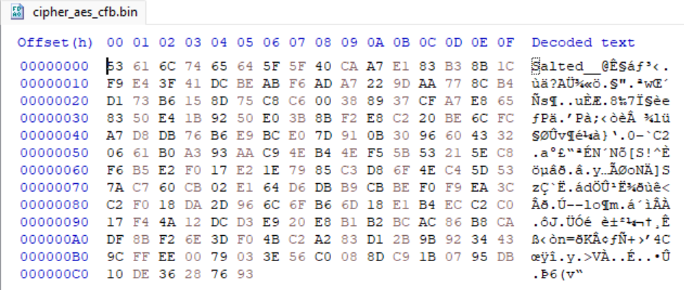

Corrupted Encrypted Text

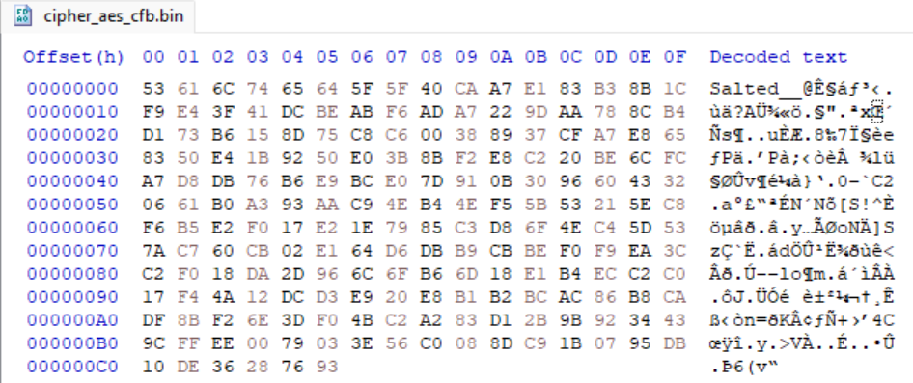

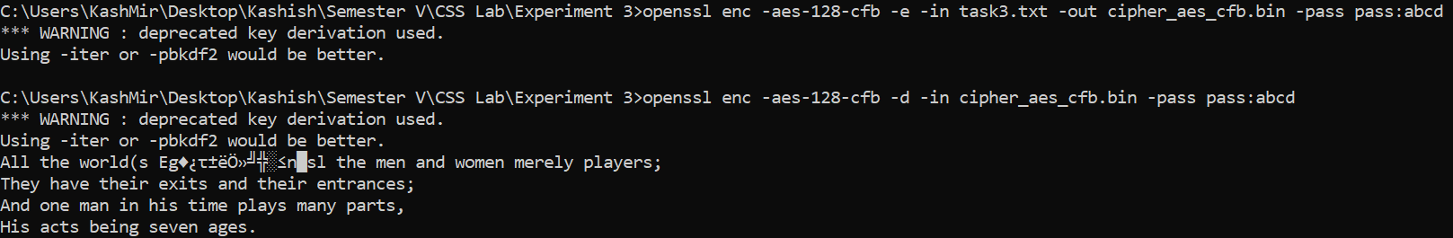

**OFB**

Original Encrypted Text 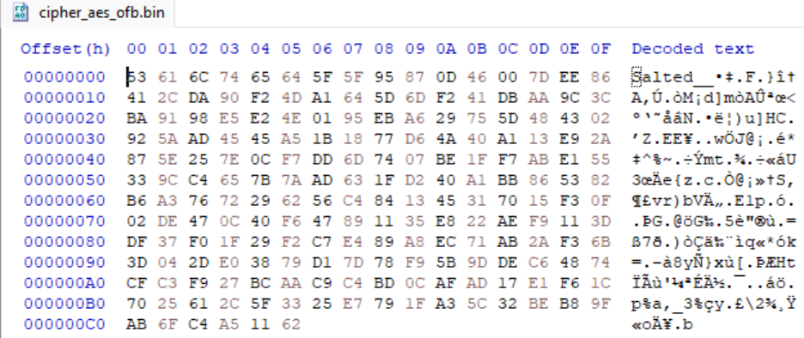

Corrupted Encrypted Text

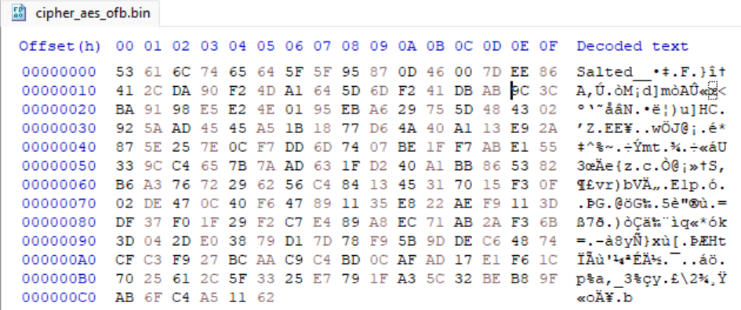

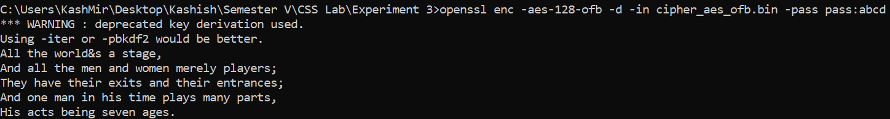

**Observation**

* ECB - When a ciphertext error occurs in ECB mode, only one block is affected. Each block must be decoded separately. However, because we decrypt one block at a time, the faulty bit of the 30th byte in ciphertext block 8 bytes could propagate to all n bits in plaintext block 8 bytes.
* In CBC and CFB more than 1 bit in the decrypted text were corrupted when you changed 1 bit in the ciphertext.
* OFB - The single digit of the 30th byte is corrupted in OFB mode, and subsequently only that byte or character is corrupted in plain text. As a result, only the OFB mode yields the best results, with nearly all the sentences retrieved.

Task 4: Padding

For block ciphers, when the size of the plain text is not the multiple of the block size, padding may be required.

In this task, we will study the padding schemes. Please do the following exercises:

1. The openssl manual says that openssl uses PKCS5 standard for its padding. Please design an experiment to verify this. In particular, use your experiment to figure out the paddings in the AES encryption when the length of the plaintext is 20 octets and 32 octets.
2. Please use ECB, CBC, CFB, and OFB modes to encrypt a file (you can pick any cipher). Please report which modes have paddings and which ones do not. For those that do not need paddings, please explain why.

**Original file (20 octets)**

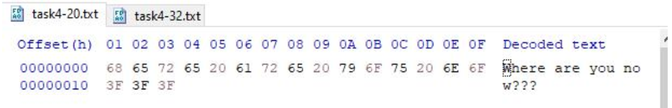

**Original file (32 octets)**

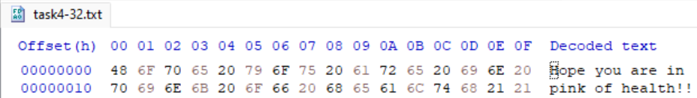

1. CBC

Aes-128-cbc for 20 octets

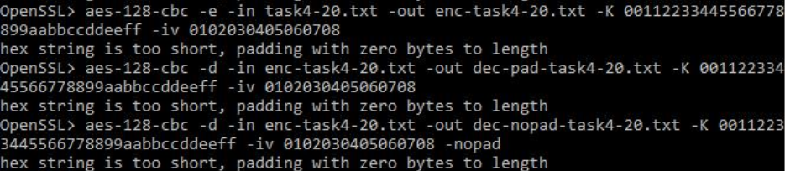

Encrypted File

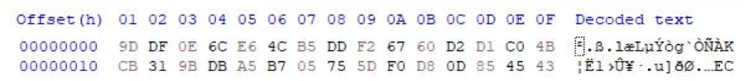

Decrypted file (Without padding)



Decrypted file (With padding)



Aes-128-cbc for 32 octets

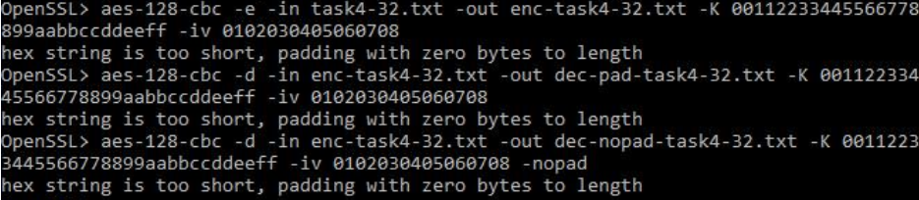

Encrypted file

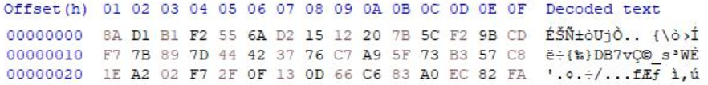

Decrypted file (Without padding)

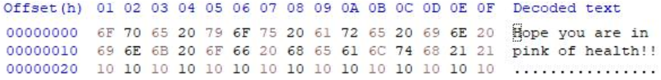

Decrypted file (With padding)

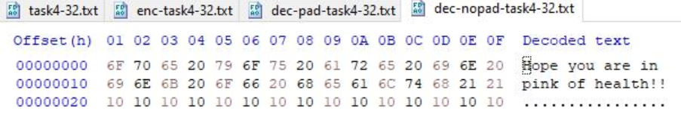

1. ECB

Aes-128-ecb for 20 octets

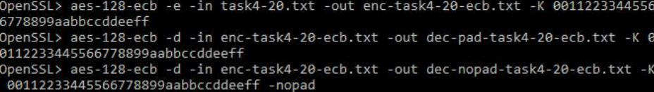

Encrypted File

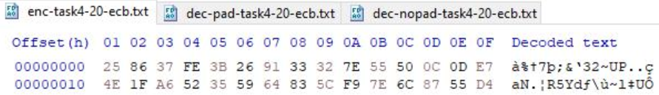

Decrypted file (Without padding)



Decrypted file (With padding)



Aes-128-ecb for 32 octets

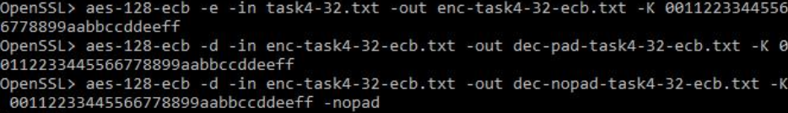

Encrypted file

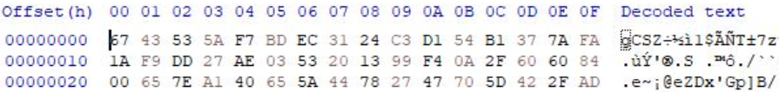

Decrypted file (Without padding)



Decrypted file (With padding)

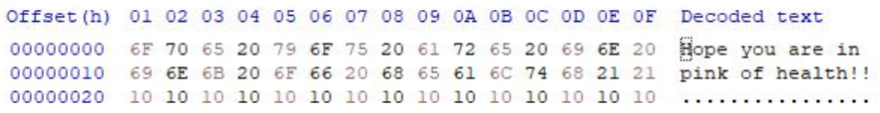

1. CFB

Aes-128-cfb for 20 octets

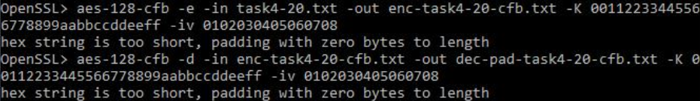

Encrypted File

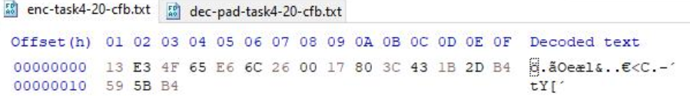

Decrypted file (Without padding)

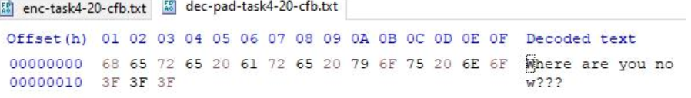

Decrypted file (With padding)



Aes-128-cfb for 32 octets

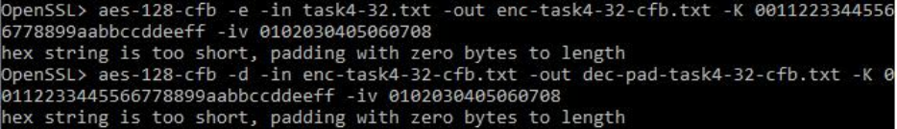

Encrypted file

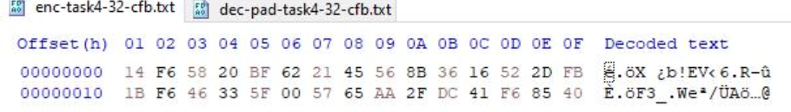

Decrypted file (Without padding)

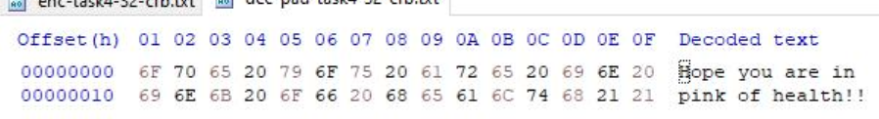

Decrypted file (With padding)



1. OFB

Aes-128-ofb for 20 octets

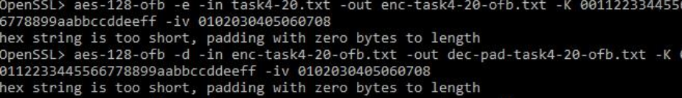

Encrypted File

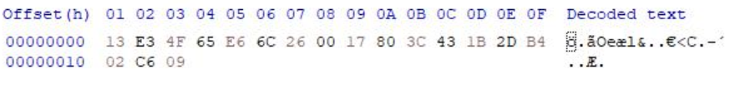

Decrypted file (Without padding)

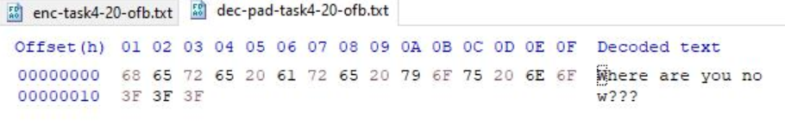

Decrypted file (With padding)



Aes-128-ofb for 32 octets

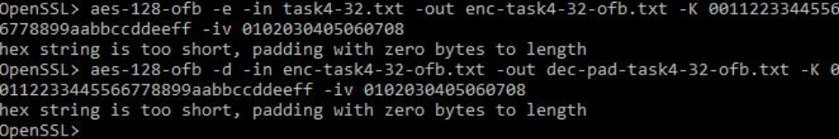

Encrypted file

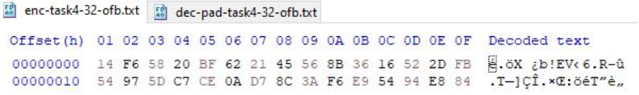

Decrypted file (Without padding)

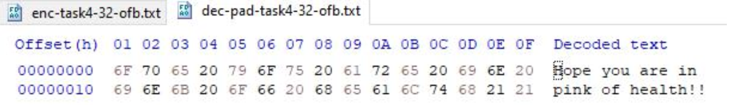

Decrypted file (With padding)



The size of CBC and ECB encrypted files with the nopad option is 12 bytes more for the 20 bytes file and 16 bytes larger for the 32 bytes file, however the size of OFB and CFB decrypted files is the same, as shown in the screenshots above.

**Observations**

* Padding is required for ECB and CBC encryption techniques, according to the experiment. This could be due to the fact that ECB and CBC are block cyphers, and the length of input for a block cypher must be an exact multiple of the block length. If this isn't the case, padding will have to be applied to make it so. After decryption, this padding is deleted.
* Because OFB and CFB are stream cyphers, the ciphertext is always the same length as plain text, padding is not necessary.

Task 5: Programming using the Crypto Library

So far, we have learned how to use the tools provided by openssl to encrypt and decrypt messages. In this task, we will learn how to use openssl’s crypto library to encrypt/decrypt messages in programs.

OpenSSL provides an API called EVP, which is a high-level interface to cryptographic functions. Although OpenSSL also has direct interfaces for each individual encryption algorithm, the EVP library provides a common interface for various encryption algorithms. To ask EVP to use a specific algorithm, we simply need to pass our choice to the EVP interface. A sample code is given in http://www.openssl. org/docs/crypto/EVP_EncryptInit.html.

Activate MyEnv

Please get yourself familiar with this program, and then do the following exercise. You are given a plaintext and a ciphertext, and you know that aes-128-cbc is used to generate the ciphertext from the plaintext, and you also know that the numbers in the IV are all zeros (not the ASCII character ‘0’). Another clue that you have learned is that the key used to encrypt this plaintext is an English word shorter than 16 characters; the word that can be found from a typical English dictionary. Since the word has less than 16 characters (i.e. 128 bits), space characters (hexadecimal value 0x20) are appended to the end of the word to form a key of 128 bits. Your goal is to write a program to find out this key. You can download a English word list from the Internet. We have also linked one on the web page of this lab. The plaintext and ciphertext is in the following:

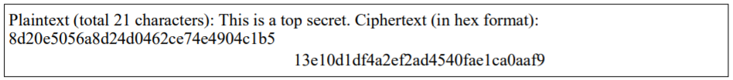

Words.txt file

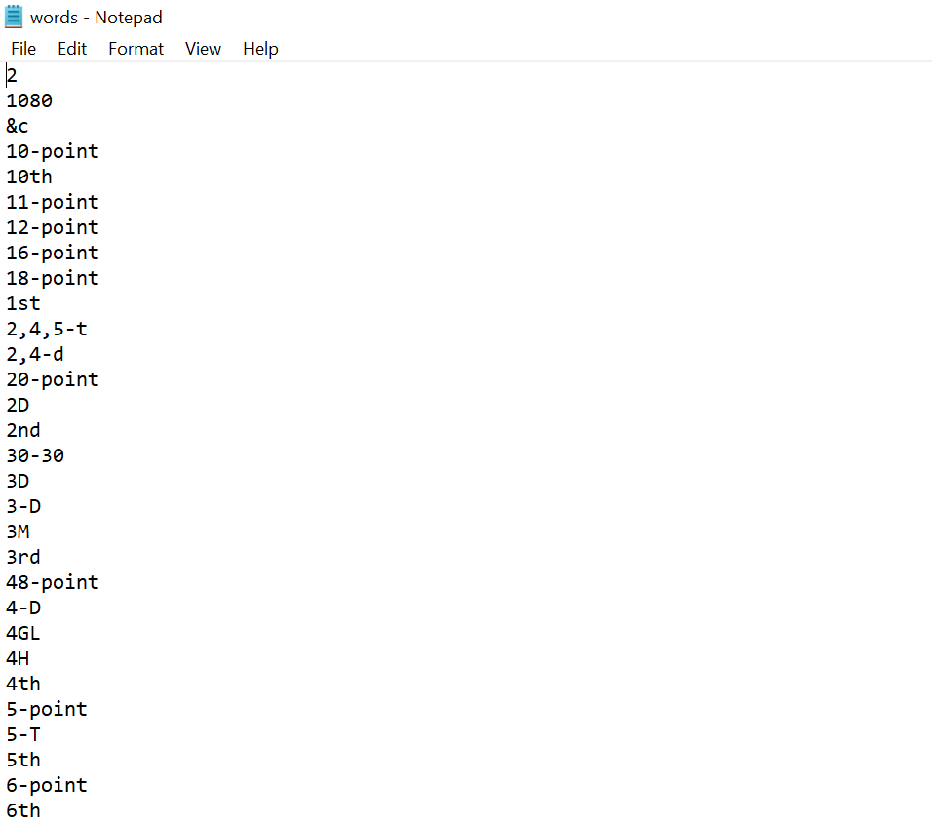

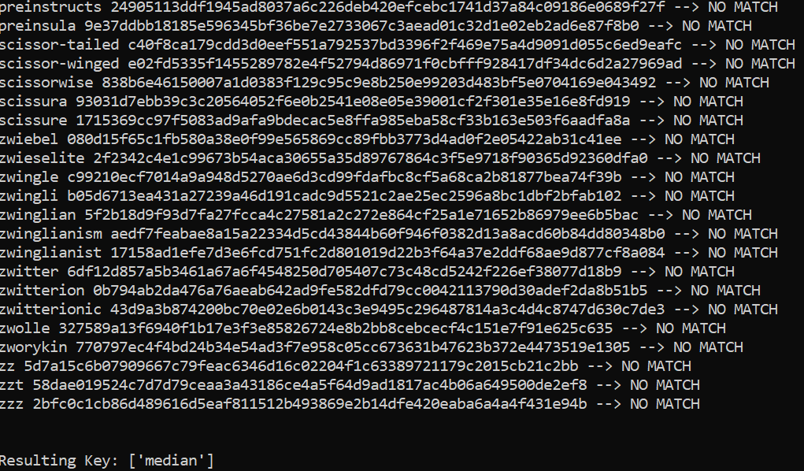

Code

from Crypto.Cipher import AES

from Crypto.Util.Padding import pad

cipherHex = "8d20e5056a8d24d0462ce74e4904c1b513e10d1df4a2ef2ad4540fae1ca0aaf9"

plainText = b"This is a top secret."

result = []

file = open('words.txt', 'r')

lines = file.readlines()

words = [str.strip(line) for line in lines]

for word in words:

if len(word) >= 16:

continue

word = word.lower()

key = word.encode() + b' '*(16-len(word))

cipher = AES.new(key, AES.MODE_CBC, iv=bytes.fromhex('0'*32))

ciphertext = cipher.encrypt(pad(plainText, AES.block_size))

is_matched = "--> NO MATCH"

if bytes.hex(ciphertext) == cipherHex:

is_matched = "--> MATCH"

result.append(word)

print(word, bytes.hex(ciphertext), is_matched)

print("\n\nResulting Key:",result)

**The key is “median”**

**Conclusion**

* In this experiment, I learned about various encryption methods such as AES and their different encryption modes such as ECB, CBC, CFB, OFB, etc and I implemented them using Openssl utility.
* ECB mode encrypts the identical plain text blocks to identical encrypted text blocks and hence it is less secure.
* From the experiment, I deduced that ECB and CBC employ padding while encrypting, whereas the other two don't. ECB and CBC are block cyphers, but CFB and OFB are stream cyphers, as evidenced by this.
* In OFB mode, if the single digit of the 30th byte corrupted, then in plain text that only that byte or character is corrupted. Thus, only OFB mode shows the most promising result in task 3 and almost all the texts are recovered.
* I concluded from task 5 that if I have the ciphertext and the key space, I can easily locate the plaintext using the brute force method.

**Github Links**

Repository

<https://github.com/kashishvjain/CSS-Lab>